Template Public Law orders
February 2025
To be used in all public law matters.

- Gatekeeping order for listing the initial hearing when the ICO hearing is not urgent, listing 12-18 days:

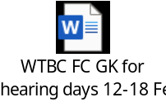

- Gatekeeping order for listing the initial hearing when an urgent hearing is required.

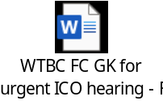

- Case management order to be completed at the end of an urgent ICO hearing, which lists the case for the case management hearing between days 12-18.

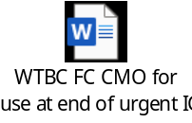

- Case management order for use at the case management hearing (heard between days 12-18) which lists to IRH or another CMH.

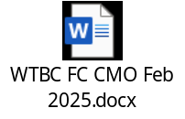

NOTE: The court completes the gatekeeping orders, when the application is made. They are included in this document to explain the whole processs
The two orders at No’s 2 and 3 above are essentially the normal GK order, No 1, but split into two parts. When an urgent ICO hearing is listed at gatekeeping, there will be no time to respond to threshold etc in advance. Directions are therefore made at the conclusion of the urgent ICO hearing, and the case should then be listed for a substantive case management hearing between days 12-18.
In a table it looks like this:
 | Urgent ICO hearing Req | ICO within day 12-18
GK order made
On application
Order to be used at end of urgent ICO hearing
CMH day12-18

- Short form order for FCMH if appropriate:

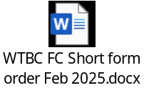

- Final hearing order:
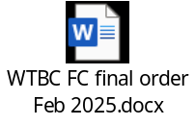
- Medical records orders:

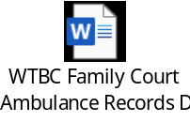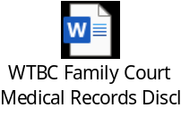

- DWP/HMRC Orders:

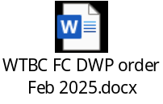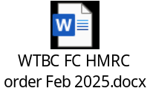

- C2 template orders. These are for use when a C2 needs to be made on the FPL.

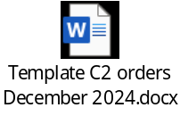

- Witness template.

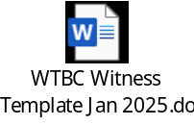

- Advocates meeting agenda.

